Boxplots: Problem 2
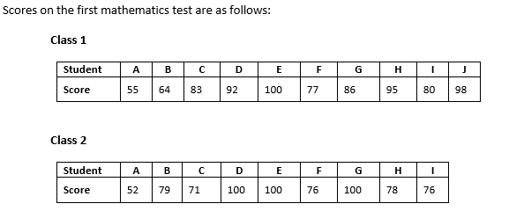
1. Make a boxplot of each set of data.
Class 1

Class 2

2. Identify the LE, LQ, Med, UQ, and UE of each.

3. What is the IQR of Class 1? __________________ Class 2? __________________

4. Which class did better? ______________ How do you know this?

